TERRAFORM FINAL TASK

Create VPC
resource "aws_vpc" "my_vpc" {
cidr_block = "10.0.0.0/16"
tags = {
Name = "my-vpc"
}
}
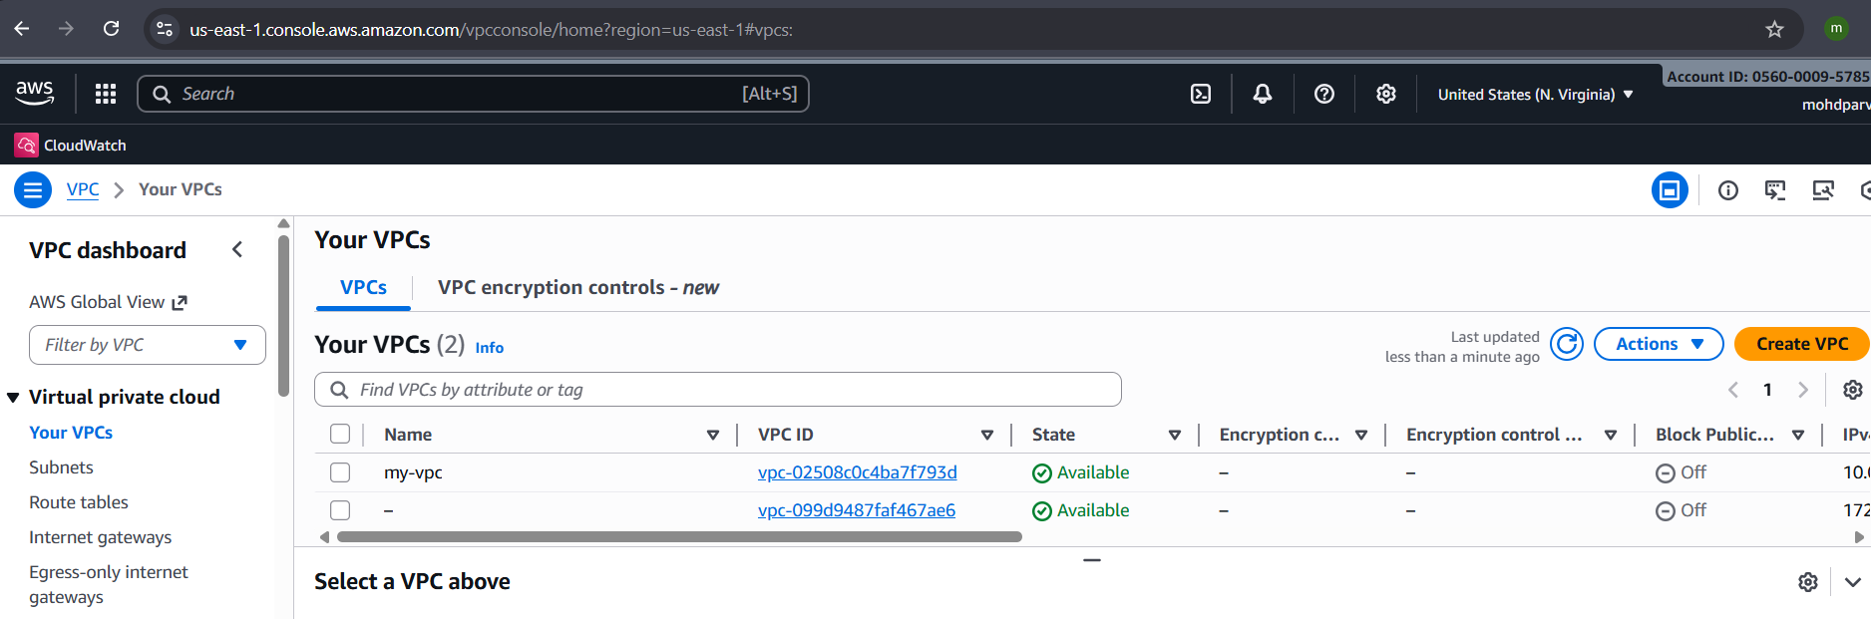

Create Internet gateway
resource "aws_internet_gateway" "my_igw" {
vpc_id = aws_vpc.my_vpc.id

tags = {
Name = "my-igw"
}
}
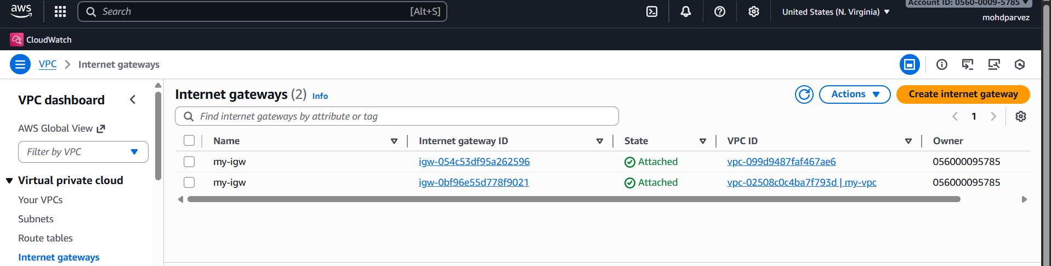

Create Custom Route Table
resource "aws_route_table" "my_rt" {
vpc_id = aws_vpc.my_vpc.id

route {
cidr_block = "0.0.0.0/0"
gateway_id = aws_internet_gateway.my_igw.id
}

tags = {
Name = "my-rt"
}
}

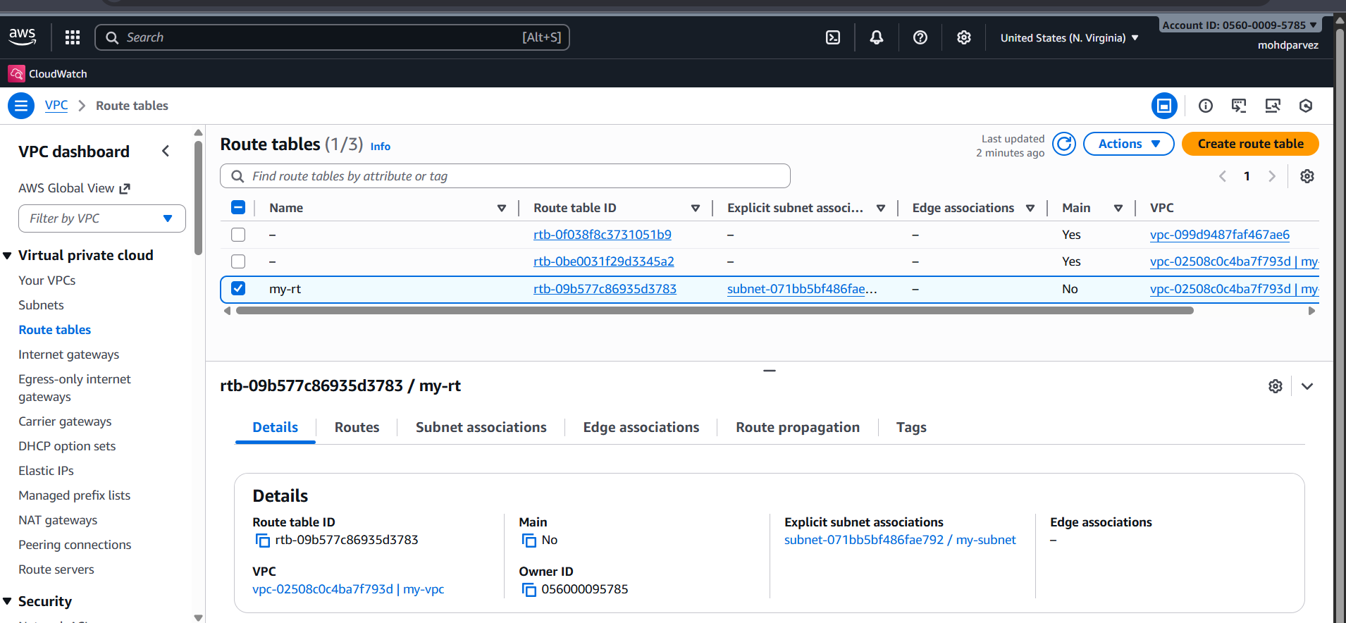

Create Subnet
resource "aws_subnet" "my_subnet" {
vpc_id = aws_vpc.my_vpc.id
cidr_block = "10.0.1.0/24"
availability_zone = "us-east-1a"
map_public_ip_on_launch = true

tags = {
Name = "my-subnet"
}
}
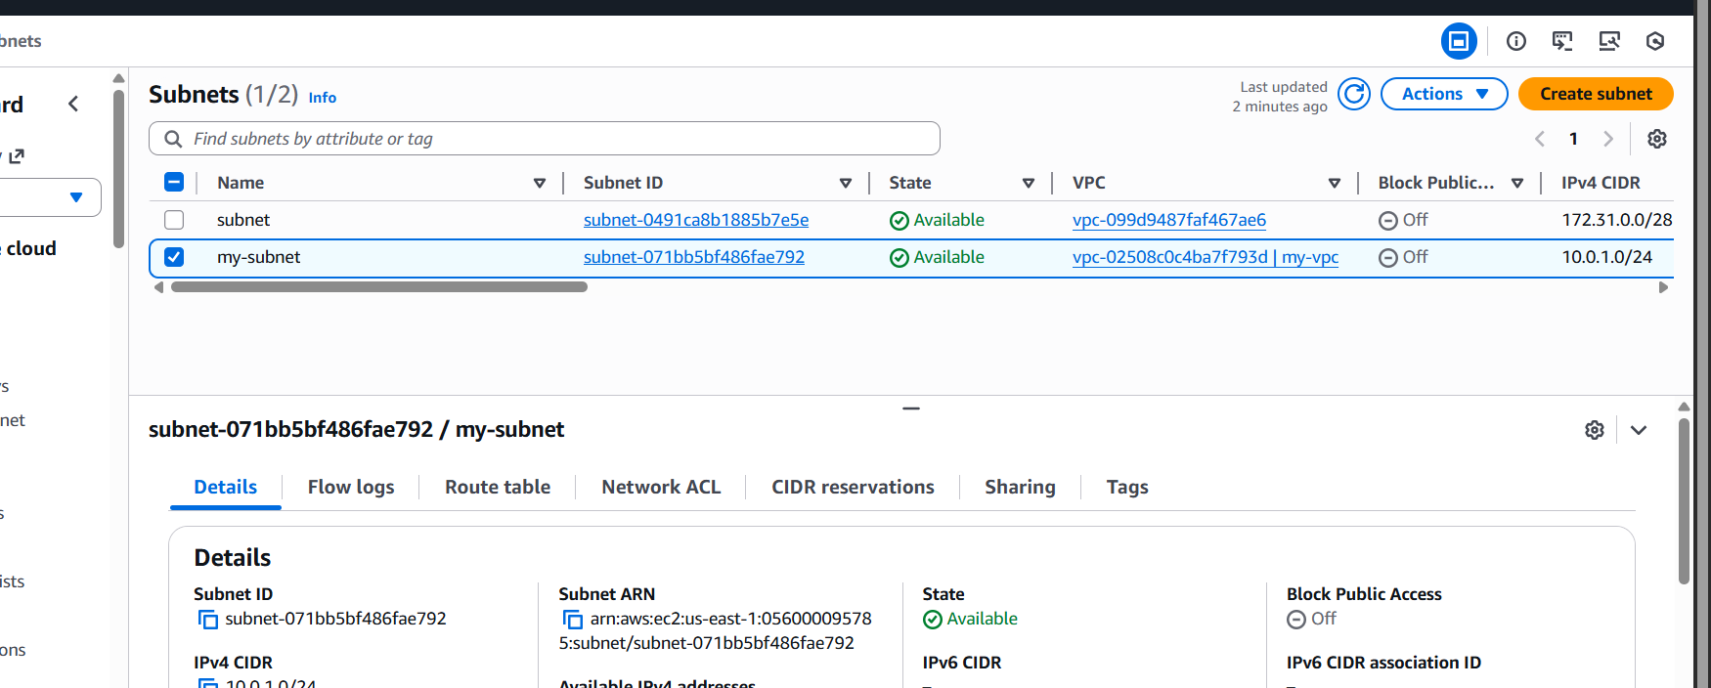

Associate subnet with Route Table
resource "aws_route_table_association" "my_rta" {
subnet_id = aws_subnet.my_subnet.id
route_table_id = aws_route_table.my_rt.id
}
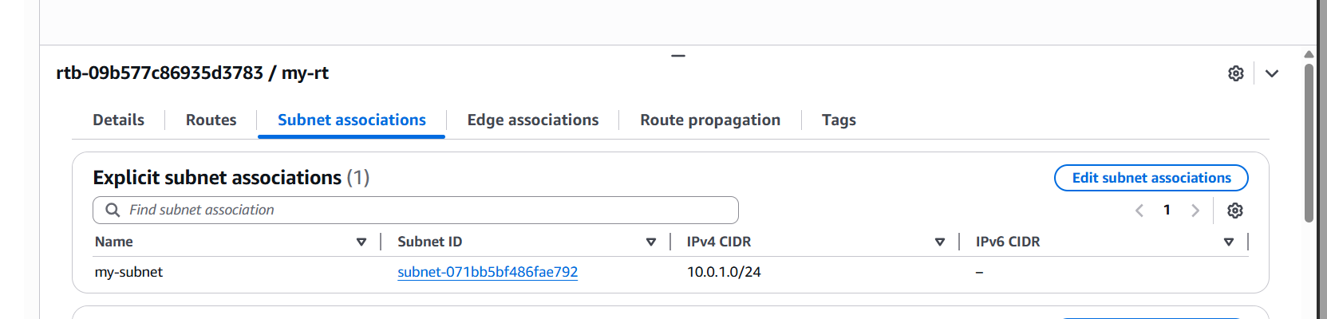

Create Security Group to allow port 22.80,443
resource "aws_security_group" "my_sg" {
name = "allow-web-ssh"
description = "Allow SSH, HTTP, HTTPS"
vpc_id = aws_vpc.my_vpc.id

ingress {
from_port = 22
to_port = 22
protocol = "tcp"
cidr_blocks = ["0.0.0.0/0"]
}

ingress {
from_port = 80
to_port = 80
protocol = "tcp"
cidr_blocks = ["0.0.0.0/0"]
}

ingress {
from_port = 443
to_port = 443
protocol = "tcp"
cidr_blocks = ["0.0.0.0/0"]
}

egress {
from_port = 0
to_port = 0
protocol = "-1"
cidr_blocks = ["0.0.0.0/0"]
}

tags = {
Name = "web-ssh-sg"
}
}

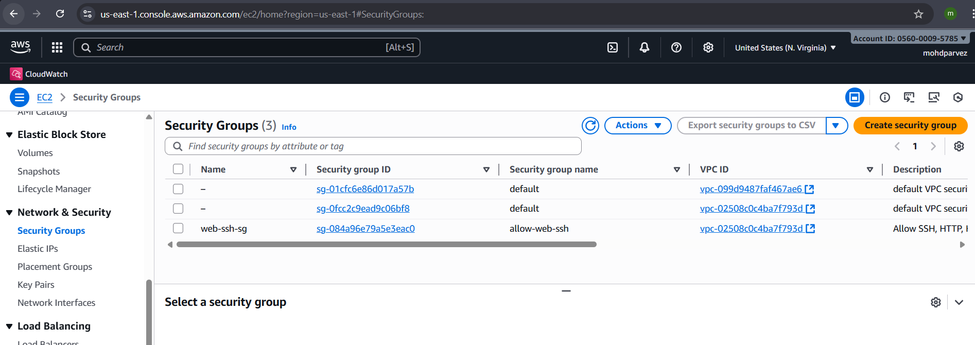

Create a network interface with an ip in the subnet that was created in step 4
resource "aws_network_interface" "my_eni" {
subnet_id = aws_subnet.my_subnet.id
private_ips = ["10.0.1.50"]
security_groups = [aws_security_group.my_sg.id]

tags = {
Name = "my-eni"
}
}
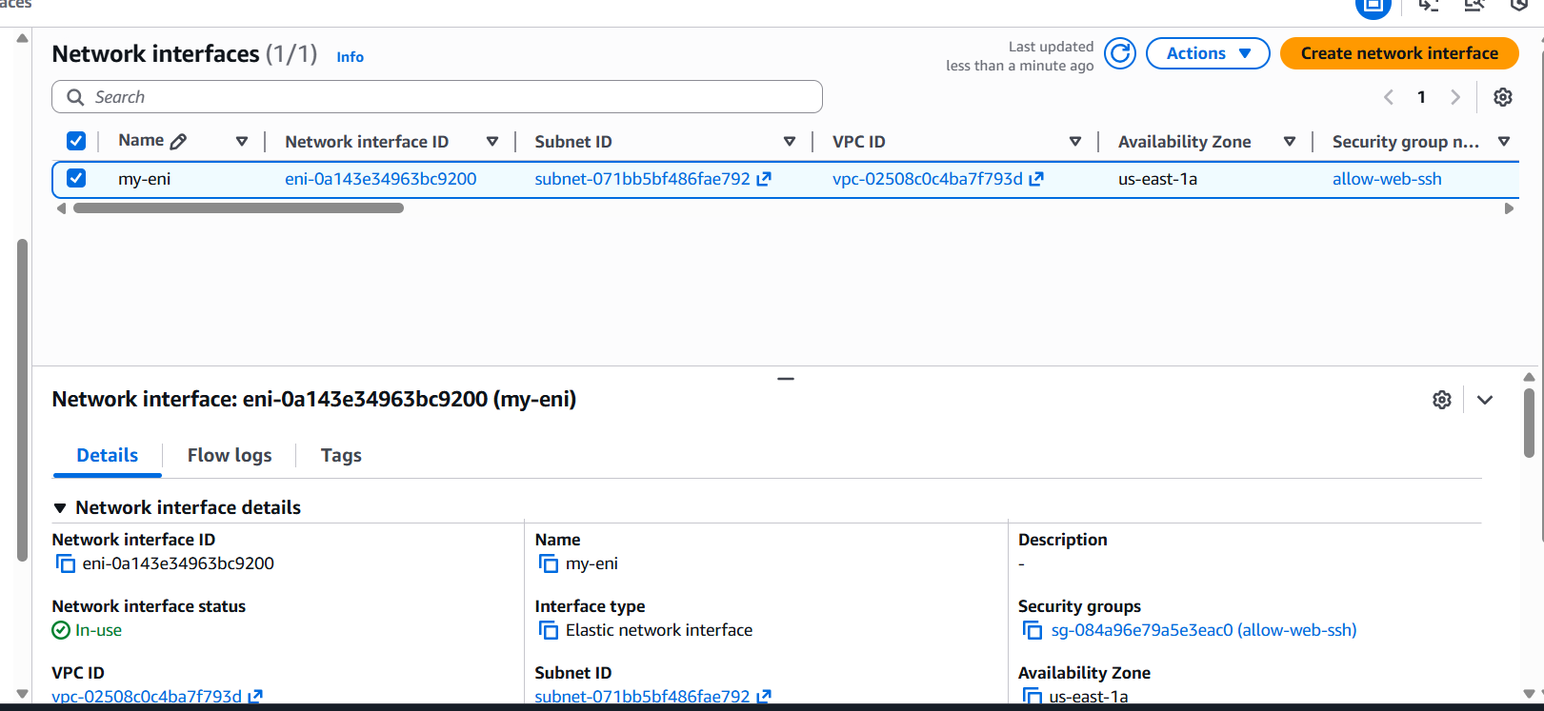

Assign an elastic IP to the network interface created in step 7
resource "aws_eip" "my_eip" {
domain = "vpc"
network_interface = aws_network_interface.my_eni.id
depends_on = [aws_internet_gateway.my_igw]

tags = {
Name = "my-eip"
}
}
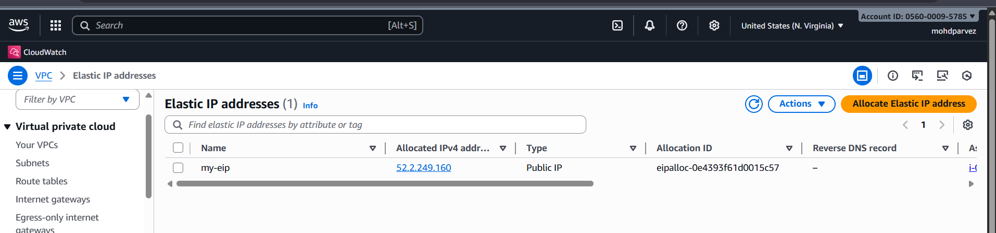

Create Ubuntu server and install/enable apache2
resource "aws_instance" "ubuntu_server" {
ami = "ami-0ecb62995f68bb549" # Ubuntu 22.04 LTS in us-east-1
instance_type = "t3.large"
key_name = "asg-key" # <-- change this

network_interface {
device_index = 0
network_interface_id = aws_network_interface.my_eni.id
}

user_data = <<-EOF
#!/bin/bash
apt update -y
apt install -y apache2
systemctl enable apache2
systemctl start apache2
EOF

tags = {
Name = "ubuntu-apache-server"
}
}

